|  |  |  |  |  |  |
| --- | --- | --- | --- | --- | --- |
| **Key Vocabulary** | | | | | |
| **Sprint** | **Aiming**  603 Basketball Free Throw Royalty-Free Images, Stock Photos & Pictures |  Shutterstock | | **Relay** | | **Grip** |
| **What you need to be successful?** | | | | | |
| **How to run fast (sprint)** | | **How to aim** | | **How to pass something to a partner.** | |
| * Look forward. * Take short steps. * Breath in and out. * Move your arms as you run. | | * Look at where you are throwing. * Point your shoulder to your target. * Legs apart. * Good grip of your ball. | | * Look at your partner. * Move slowly towards your partner. * Pass the object to your partner. | |
| **Building Blocks to Success** | | | | | |

**Pictures of Skills**

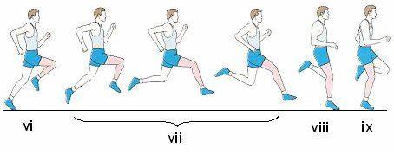

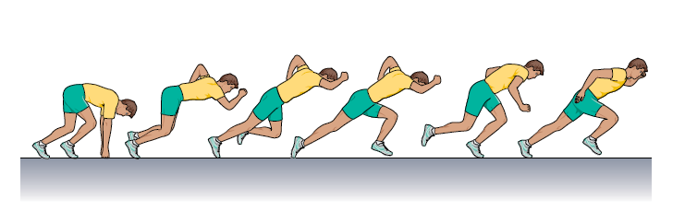

**Sprinting Technique**

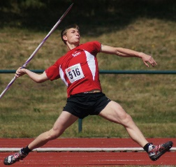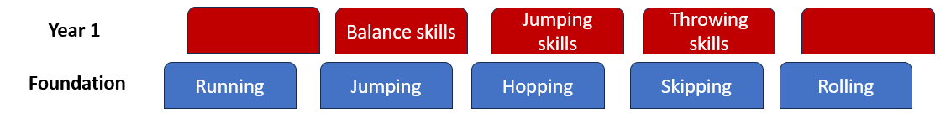

**Aiming Technique**

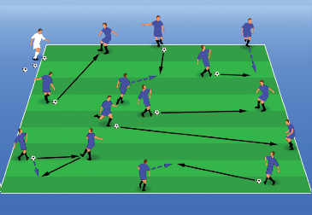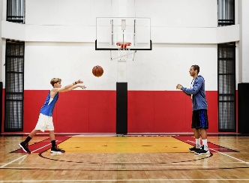

**Passing**